SALMON RIVER HIGH ADVENTURE BASE

2018 Leader’s Guide

2018 Leader’s Guide

Grand Teton Council

Welcome to Salmon River High Adventure Base
Salmon River High Adventure Base is one of the unique camp destinations for older Boy Scout troops, Varsity teams, and Venture crews. We are one of the few camps in the United States to offer both rafting and kayaking, and we do it on what is rightly considered to be one of the country’s best rivers for whitewater.

“River of No Return”
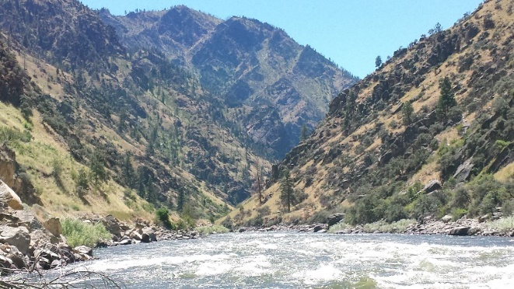
Idaho’s Salmon River is one of the most idyllic in the United States. Beginning in the mountains above the Sawtooth Valley, it flows north through central Idaho before turning sharply west at the town of North Fork. From there, it flows through the deep canyons of the Salmon River and Clearwater Mountains—some of the most rugged and isolated terrain in the contiguous United States—before it joins the Snake River just 15 miles from the Washington border.

The Salmon River is often called the “River of No Return,” not because it is dangerous but because it is fast. It drops 7,000 feet along the 425 miles that separate its headwaters and its confluence, an average of 16 feet of elevation lost for every river mile. It is also one of the longest free-flowing, undammed rivers in the continental United States, second only to the Yellowstone. And thanks to a coincidence of geography, the entire river is contained within the state’s borders, making the Salmon River a true Idaho original.

Our Legacy
The kayak program that would eventually grow into Salmon River High Adventure Base began on the upper reaches of the Snake River in 1966. For several summers, participants would be guided down the well-traveled and familiar rapids of the Snake River. It wasn’t until a suggestion from Walt Blackadar, a Salmon doctor and kayaking legend, that the staff packed up their boats and made the long drive to Lemhi County. After their first run down the Salmon, personally guided by Walt, the staff realized what thousands of Scouts have since learned: the famous “River of No Return” offers a superior whitewater experience.

For many years, the Salmon River high adventure program operated out of the Spring Creek area. But the search was on for a new facility from which to run. In 1986, Teton Peaks Council acquired 19 prime acres of river-fronted property from Mr. and Mrs. Roscoe Grover of Salmon, Idaho. Facilities were constructed, and the base saw its first use the next summer. It has since hosted thousands Scouts, each coming away with a Salmon River experience that cannot be found anywhere else.

`.
Adult Leadership
The role of adult leadership for summer camp cannot be overstated. In planning, preparing, and participating, their influence and example is critical. The best available adult leadership should be recruited to accompany each unit to Salmon River High Adventure Base. At minimum, the unit must have two registered adult leaders, or one registered leader and a parent of a participating Scout or other adult, one of whom must be at least 21 years of age. For Venture Crews, all adults must be at least 21 years of age. For coed Venture Crews, there must be at least one female and one male advisor, both of whom must be at least 21 years of age. Please refer to Guide to Safe Scouting, No. 34416, for additional adult leadership policies

Archery
Salmon River High Adventure Base has an archery range. It will be open for participant use from 7:00-9:00 pm on Day 1 and 7:00-8:30 pm on Day 2 of each session.

Buddy System
Leaders should encourage the use of the buddy system for all participants, whether in camp or on the river.
Camp Accommodations
Salmon River High Adventure Base provides platform tents and a few teepees for participants to sleep in. However, each participant is responsible for bringing their own cot/sleeping pad and sleeping bag. In order to accommodate everyone, youth will sleep four to a tent and adults will sleep two to a tent. In keeping with BSA Youth Protection Policies, there are separate accommodations for males and females, and youth and adults. There is to be no more than a three-year age gap between Scouts tenting together. No youth may share a tent with an adult other than his or her own parent or legal guardian.

Camp Bell
During camp orientation, participants will be shown the camp bell. It is used to announce mealtimes and honor trail/campfire, as well as for emergencies. The emergency bell is distinct, and will be demonstrated. If the emergency signal is sounded, participants should report to the camp fire bowl to receive instructions.

Check-in Procedures
Check-in will begin at 8:00 am at the camp dining hall. Each unit will need to provide:
- a copy of the Tour and Activity Plan and Unit Accident Insurance Policy
- a completed Unit Roster Form

- a BSA Annual Health and Medical Record for each participant
- the balance of fees due, if any
Following check-in, a camp orientation meeting will be held at 9:00 am in the camp dining hall.

Check-out Procedures
Check-out will begin after lunch on the final day of each session. Leaders will receive the BSA Annual Health and Medical Records on file for their unit and will have the opportunity to evaluate their unit’s experience at Salmon River High Adventure Base.

Climbing and Rappelling
Salmon River High Adventure Base has a climbing wall. It will be open for both climbing and rappelling from 7:00-9:00 pm on Day 1 and 7:00-8:30 pm on Day 2 of each session. It is natural rock, and long pants are recommended. Close-toed shoes are required. Any personal gear must be approved by the Climbing Director.

Disc Golf
Salmon River High Adventure Base boasts one of the best disc golf courses in Grand Teton Council. Participants may bring their own discs, or may check out discs from the camp trading post. Score sheets are available from the trading post.

Duty to God
The Boy Scouts of America is an interfaith organization that encourages each member to actively participate in his or her individual religious beliefs and responsibilities. To facilitate a Scout’s Duty to God, units may request access to the fire bowl for a period of thought, discussion, and reflection. Grace will be said before each meal, and every participant may have the opportunity to offer prayer according to their personal faith tradition.

Early Arrivals
If necessary, units may arrive the night before their session begins. All early arrivals must notify the camp director at least one week in advance by emailing whatdasnell@yahoo.com. Plan to arrive at Salmon River High Adventure Base between 5:00 pm and 8:30 pm on Sunday evening (for Monday-Wednesday sessions) or Wednesday evening (for Thursday-Saturday sessions). No river crossings will be made after 9:00 pm. All units arriving early must have appropriate leadership as defined by Guide to Safe Scouting, No. 34416. Upon request, Salmon River High Adventure Base will provide breakfast for any early arrivals at a cost of $6/person.

Electronics
Participants should take care with any electronics they may choose to bring with them to Salmon River High Adventure Base. There is no cell reception anywhere in camp, and the ability to charge such devices is limited. Salmon River High Adventure Base and Grand Teton Council are not responsible for lost, damaged, or stolen devices.
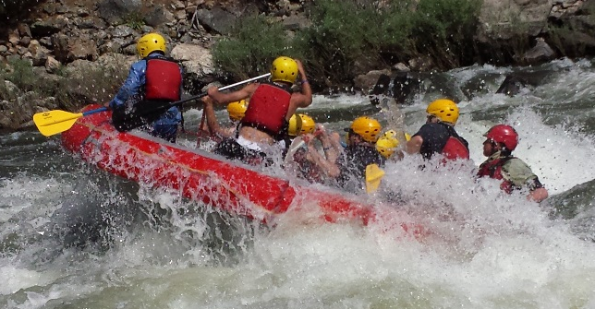

Equipment List

Though all required program gear—including tents, kayaks, and safety equipment—are provided by Salmon River High Adventure Base, participants still have a responsibility to bring their own personal equipment. Such equipment includes:

- Sleeping Bag
- Sleeping Pad/Cot
- Swimsuit
- Jacket
- River-appropriate Clothing (no cotton)
- River-appropriate Shoes (no flip-flops)
- Camp-appropriate Clothing
- Sun Screen
- Mosquito Repellant
- Toiletries and Personal Items

Personal wetsuits and spray jackets can make an overcast day more comfortable, but are not required. Any participant wishing to climb must have close-toed shoes. When packing, remember that the average daily temperature variance is 35 degrees.

Fire
The smallest spark as the potential to start a fire that can burn thousands of acres and cost millions of dollars. To help protect Salmon River High Adventure Base and the Salmon-Challis National Forest from fire, campfires are only allowed in the camp fire bowl by the permission of the camp director and under the qualified supervision of unit leaders. No fireworks are allowed in camp.

First Aid
Salmon River High Adventure Base is prepared to meet the emergency needs of all participants. The camp first aid office is located in the left half of the duplex. In addition, first aid kits can be found at the dining hall, waterfront, and on each bus. All injuries must be reported and recorded by the First Aid Officer.

Fishing
Fishing the Salmon River is an experience many people only dream about. Any participant who would like to fish must bring their own equipment and have a valid Idaho fishing license, available at the Village, located 13 miles upriver in North Fork, ID. Fishing is not allowed on the beach or from any camp boats. Participants are responsible for knowing all regulations governing the Salmon River.

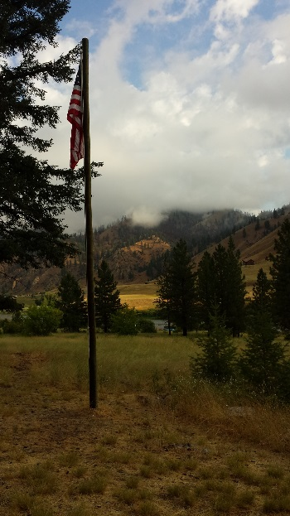
Flag Ceremonies
Recognizing a Scout’s Duty to Country, the Salmon River High Adventure Base staff will have a short flag ceremony every day at 7:45 am, after which breakfast will be served. All participants are invited to attend.

Float Check
Before running the river, each participant will be required to successfully perform a float check. This consists of:
- Correctly wearing an approved PFD and whitewater helmet
- Jumping feet first into moving water
- Orienting yourself face up with feet downstream
- Float for 25 yards negotiating waves, and

Personal wetsuits and spray jackets can make an overcast day more comfortable, but are not required. Any participant wishing to climb must have close-toed shoes. When packing, remember that the average daily temperature variance is 35 degrees.

Fire
The smallest spark as the potential to start a fire that can burn thousands of acres and cost millions of dollars. To help protect Salmon River High Adventure Base and the Salmon-Challis National Forest from fire, campfires are only allowed in the camp fire bowl by the permission of the camp director and under the qualified supervision of unit leaders. No fireworks are allowed in camp.

First Aid
Salmon River High Adventure Base is prepared to meet the emergency needs of all participants. The camp first aid office is located in the left half of the duplex. In addition, first aid kits can be found at the dining hall, waterfront, and on each bus. All injuries must be reported and recorded by the First Aid Officer.

Fishing
Fishing the Salmon River is an experience many people only dream about. Any participant who would like to fish must bring their own equipment and have a valid Idaho fishing license, available at the Village, located 13 miles upriver in North Fork, ID. Fishing is not allowed on the beach or from any camp boats. Participants are responsible for knowing all regulations governing the Salmon River.

Flag Ceremonies
Recognizing a Scout’s Duty to Country, the Salmon River High Adventure Base staff will have a short flag ceremony every day at 7:45 am, after which breakfast will be served. All participants are invited to attend.

Float Check
Before running the river, each participant will be required to successfully perform a float check. This consists of:
- Correctly wearing an approved PFD and whitewater helmet
- Jumping feet first into moving water
- Orienting yourself face up with feet downstream
- Float for 25 yards negotiating waves, and
- Safely exiting the current to shore

Food Service
Salmon River High Adventure Base provides a full-service dining hall for all participants during the extent of their session, beginning with lunch of the first day and ending with lunch of the third day. Shirts and shoes must be worn during each meal. If any participant has special dietary requirements, please notify the camp director at least two weeks in advance by emailing whatdasnell@yahoo.com

Guests
If any unit has guests joining them during their stay at Salmon River High Adventure Base, they must check in with the camp business manager as soon as they arrive. They are welcome to stay for meals, at a cost of $6/meal. They will not be allowed to go down the river or to stay overnight.

Honor Trail/Campfire
On the second evening of each session, the staff of Salmon River High Adventure Base will put on an honor trail and, conditions permitting, a small campfire.

Medical Forms
All participants, adult and youth, must have a current BSA Annual Health and Medical Record—Parts A, B, and C—signed by a certified and licensed health-care provider: a physician (MD or DO), a nurse practitioner, or a physician assistant. This form is valid for 12 calendar months. Anyone arriving in camp without a current, completed, and signed health and medical form will not be allowed to participate in the camp program.
Participation Requirements
All participants must be at least 14 years old by September 1, 2015. They must have passed a BSA swimmer test and have a current BSA Annual Health and Medical Record—Parts A, B. and C—signed by a certified and licensed health-care provider: a physician (MD or DO), a nurse practitioner, or a physician assistant. All participants under the age of 21 must be a registered member of the Boy Scouts of America.

Phone
Salmon River High Adventure Base is located in the Beaverhead

Mountains, just a few miles from the Continental Divide. Being such a remote area, there is no cell phone reception. There is no public phone available in camp.

Program Gear
Salmon River High Adventure Base will provide each participant with any program equipment they will need during each session. Upon arrival, each participant will be issued a PFD and helmet for their personal use during their stay. Boats and paddles will likewise be provided. Participants will be held responsible for any equipment missing or broken due to neglect or misuse.

Quiet Hours
Salmon River High Adventure Base receives all of its electric power from a generator station located near the dining hall. The generator runs from 7:00 am to 11:00 pm each day. While the generators are off, quiet hours

Quiet hours are strictly enforced. Please note that the generator area is off-limits to all participants.

Restrooms
Salmon River High Adventure Base has five separate toilets located within the shower house. All are clearly marked for their intended use. Participants must use the appropriate restroom. Participants will need to bring their own light source when the generator is shut off at 11:00 pm.

River Crossing
Salmon River High Adventure Base sits on the opposite side of the river from the parking area. All participants and their gear must cross into camp via raft. Unless precautions are taken to keep it dry, gear will most likely get wet. Dry bags and dry boxes work well, but garbage bags are almost as effective while being much more economical. No river crossings will be made after 9:00 pm, and no one will be allowed to cross the river without a staff member present.

Shower House
Salmon River High Adventure Base has a central shower house shared by all male participants and staff. Specific times are set aside for adults, a schedule of which is posted beside the door. At all other times, it is set aside for male youth. Leaders will need to bring their own light source when the generator is shut off at 11:00 pm. The generator does not affect the water heater.

Special Needs Requests
The mission of Salmon River High Adventure Base is to provide a fun and challenging program for all participants, regardless of ability level. The Salmon River High Adventure Base staff will do everything within reason to accommodate any disabilities. If any participants do require special accommodation, please notify the camp director at least one week in advance by emailing whatdasnell@yahoo.com
Swim Check
All participants attending Salmon River High Adventure Base must have passed a BSA swimmer test prior to their arrival at camp, as outlined in Aquatics Supervision, No. 34346. There is no way to accommodate a BSA swimmer test at camp.
Jump feet first into water over the head in depth. Level off and swim 75 yards in a strong manner using one or more of the following strokes: sidestroke, breaststroke, trudgen, or crawl; then swim 25 yards using an easy, resting backstroke. The 100 yards must be completed in one swim without stops and must include at least one sharp turn. After completing the swim, rest by floating.

Tobacco Policy
On request, adult leaders will be shown the designated smoking area. All smoking should be confined to that area. Any leader who wishes to use tobacco must do so discretely and not in the presence of youth. If the Forest Service issues a burn ban, no smoking will be allowed anywhere in camp.

Trading Post
Salmon River High Adventure Base has a trading post located next to the camp dining hall. It is kept stocked with a small selection of refreshments and camp souvenirs. This year, the souvenir selection includes our commemorative anniversary patch set, vinyl stickers, camp hats, and the camp t-shirt.

Travel

The address for Salmon River High Adventure Base is 1276 Salmon River Rd in North Fork, Idaho. This location is 35 miles north of Salmon, ID. From the town of Salmon, follow US-93 north for 21 miles, then turn left on NF-30/Salmon River Rd. The road will parallel the river for 13 miles before arriving at camp on the left side of the road. Travel time from Idaho Falls is 3.5 hours. Unless other arrangements have been made, units should plan to arrive by 8:00 on the first day of their session and to leave after 2:00 pm on the third day of their session. All early arrivals must notify the camp director at least one week in advance by emailing whatdasnell@yahoo.com

Uniforms
It is always appropriate to wear a Scout uniform for flag ceremonies, the honor trail, and the campfire program, but is not required. It is also not recommended to wear a Scout uniform on the river.

Unit Service Project
Salmon River High Adventure Base has a list of service projects that units can complete if they choose.

United States Forest Service
Salmon River High Adventure Base is located on property owned by Grand Teton Council, though much of our program operates on US Forest Service land. These operations are authorized under a special use permit issued by the Salmon-Challis National Forest.

Waterfront
No participant may be at the waterfront without the waterfront staff present. All participants are required to wear a PFD any time they are in a boat or in the river.

Weather
The weather of Salmon River High Adventure Base is highly variable. It could be as warm as 90 degrees and as cool as 40 degrees. All participants should come prepared for the fickle weather of central Idaho.

Wildlife
Salmon River High Adventure Base is located near one of the largest wilderness areas in the United States and it is not uncommon to see wild animals in camp. Most are relatively harmless, some are a nuisance, and a few are dangerous. Participants should keep their sleeping areas clean and limit the number of “smellables” they keep in their tent. Do not approach any animals found in camp. Any sightings of rattlesnakes, bears, or other dangerous animals should immediately be reported to the camp director.

Questions
For other questions, please contact camp director John Snell by phone at (208)313-4672, or by email at whatdasnell@yahoo.com – or Richard Turpin at the Scout office (208)522-5155 – richard.turpin@scouting.org Also be sure to check for more updates on Facebook page by searching for “Salmon River High Adventure Base.”
Scout office information
Idaho Falls – 3910 Yellowstone Ave. Idaho Falls – (208)522-5155
Pocatello – 2306 Pocatello Cr. – Pocatello – (208)233-4600
Rexburg – 59 Main St. – Rexburg – (208)359-8277
Blackfoot – 205 S. Meridian – Blackfoot – (208785-1622

Salmon River High Adventure Base
Daily Schedule
Day 1
- 8:00 am
  - Units arrive at Salmon River High Adventure Base
  - Check-in at the Dining Hall
- 9:00 am
  - Camp Orientation meeting held at the Dining Hall
  - Participants receive river assignments (raft or kayak) and prepare for the river
- 10:00 am
  - Participants receive skills introduction from their guides
- 11:30 am
  - Lunch at the Dining Hall
- 12:30 pm
  - Raft groups set off to float the middle and lower sections
  - Kayak groups cross the river to load the bus before heading to the upper section
- 5:00 pm
  - Raft groups are shuttled back to camp
  - Kayak groups float back to camp
- 6:00 pm
  - Dinner at the Dining Hall
- 7:00 pm
  - Archery, climbing wall, and waterfront open for evening program
- 9:00 pm
  - Crackerbarrel at the Dining Hall
- 11:00 pm
  - Lights out/Quiet hours begin

Day 2
- 7:45 am
  - Flag ceremony at the Parade Ground
- 8:00 am
  - Breakfast at the Dining Hall
  - Participants receive river assignments (opposite of Day 1) and prepare for the river
- 9:00 am
  - Participants receive skills introduction from their guides
  - Raft and kayak groups set off to float the middle section
- 11:30 am
  - Lunch and tour of the Hulihan Gold Mine
- 12:30 pm
  - Raft groups set off to float the lower section
  - Kayak groups load the bus to go float the upper section
- 5:00 pm
  - Raft groups are shuttled back to camp
  - Kayak groups float back to camp
- 6:00 pm
  - Dinner at the Dining Hall
- 7:00 pm
  - Archery, climbing wall, and waterfront open for evening program
- 8:30 pm
  - Program areas close in anticipation of honor trail/campfire program
  - Honor trail/campfire program begins
- 9:30 pm
  - Crackerbarrel at the Dining Hall
- 11:00 pm
  - Lights out/Quiet hours begin

Day 3
- 7:45 am
  - Flag ceremony at the Parade Ground
- 8:00 am
  - Breakfast at the Dining Hall
  - Participants chose river assignment (raft or kayak)
- 8:45 am
  - Participants cross the river to load the buses before heading to the Hulihan Gold Mine
- 10:00 pm
  - Raft and kayak groups float the lower section
- 12:30 pm
  - Raft and kayak groups are shuttled back to camp
  - Lunch at the Dining Hall
  - Check-out at the Dining Hall
- 1:00 pm
  - Units clean their sleeping area and transport personal gear to the waterfront
  - Gear and participants are ferried across the river

Thanks for visiting Salmon River High Adventure Base!

Grand Teton Council—Boy Scouts of America
Salmon River High Adventure Base
Unit Roster

No. | Full Name | Swim Check* Y/N | BSA Registered  Y/N | Medical Record**  Y/N | Age***

*All participants must have passed a BSA Swimmer Test prior to arriving at Salmon River High Adventure Base.

**All participants must have a current and valid BSA Annual Health and Medical Record. This form is valid for one year and must be signed by a doctor.

***All participants must be at least 14 years of age, or turn 14 by September 1, 2018

I certify that all participants passed BSA Swimmer Test conducted on _______ at __________________.

Unit Leader Signature: ___________________________________________ Date: _________________

