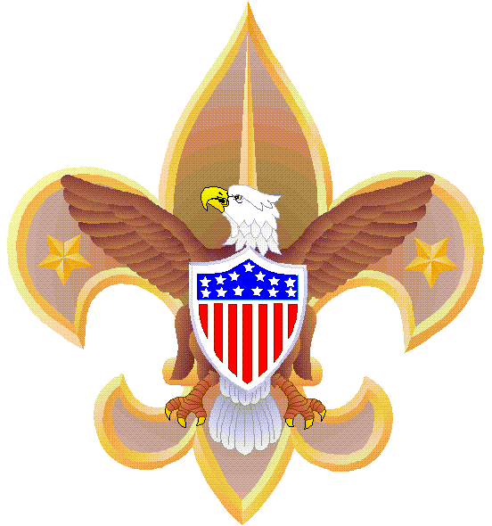
2019
Boy Scouts of America
Grand Teton Council
BLACKFOOT IDAHO DISTRICT
KLONDIKE DERBY
25-26 January 2019
At Wadsworth Island

A little history; just before the turn of the last century, gold prospectors traveled the sub-zero reaches of Alaska by means of dogs and sleds. They camped out in all kinds of winter weather, and therefore needed adequate survival skills, which they learned from the native Eskimos. Scouting has incorporated this theme in the Klondike Derby.
The point of a Klondike Derby, which usually is held in late January, is to make Scouts use their heads, to put their Scouting skills to work in the field, to demonstrate teamwork and Scout spirit, and to have fun outdoors on winter days. Keep in mind, Eskimos did not wear tennis shoes! COST is $5 per boy, Free for adults until January Roundtable. After that it will be $7 per boy and $5 for adult. Pay at the Scout Office, or at Roundtable.
Show-up any time after noon on Friday
Events
Start Saturday at 0830

-Snow blind: All patrol members, but one, are blinded (blindfolded) in a snowstorm. But the Scout who can see is injured. He must direct his fellow Scouts in raising a tent as a team. This is a timed event.
-Blindfolded Target Touch: Scouts using 6-foot poles try for a bull’s-eye on archery-like targets suspended from trees.
- Snowshoe Races: Bring your own snowshoes (Build them yourselves, Bring some you have, borrow some, or a last resort buy some)
-Survival Rope Throw: Tie and throw rescue rope to "victim" on cardboard ice flow or simulated ice break-through.
[You can also be creative as to what the victim will be sitting on. I.E. an inner-tube would be OK. A sled or toboggan would not be OK.]
- Catapult Lashing
- Dog Sled Race

-Search & Rescue: Patrol leaders are given the hiking plan of a missing solo hiker. Patrols follow the hiking plan to find a partially buried dummy that is too severely injured to move. Scouts must diagnose the dummy’s medical problems (pin a list of symptoms to the dummy’s shirt) and determine its exact location. They then send for help.
Teams are graded on their navigational skills, knowledge of first aid, use of the buddy system and the speed with which they report the dummy’s correct position back to HQ.

EQUIPMENT LIST

The boys can use anything on their sled to complete any given task. You may bring things not listed below.

Those running the events should provide any special gear the boys may need.
THE SLED
Patrol flag
Patrol roster
Pencil & paper
Clipboard & cover (or equivalent)
Watch (A stopwatch function would be excellent)
Compass
Snowshoes
Blanket
Padded splints for arms & legs
First-aid kit including four (4) cravats, gauze pads
Pocketknife (BSA requires a lock blade)
Eight (8) foot length of rope (whipped or melted)
Scout Handbook
Trash bag
CLOTHING
One of the most important parts of a Klondike Derby is to keep warm and dry.
Each Scout must know what to wear.
Winter weather is very changeable, requiring preparedness for almost any condition.
A nice day can turn into a raging blizzard.
Your best protection is your common sense.
Dress in layers.
Avoid working up a sweat, and keep yourself comfortable by removing or adding layers of clothing.
No cotton clothing [like Levis] they soak up water like a sponge and then freeze solid!
Waterproof boots are essential.
NO TENNIS SHOES!!!
Wear socks of wool or other material that wicks away perspiration.
A wool stocking cap or similar head gear with ear coverings is necessary both during the day and at night in the sleeping bag to retain warmth.

[Don’t wear your clothes to bed. Long Johns, maybe. Stockings, probably. Stocking or watch cap, definitely. Keep your clothes you are going to wear, in the bag with you, it will keep them warm so you don’t freeze getting them on in the morning. However, you may not wish to have wet clothing in the bag . . . your call.]

Scarves or ski masks are recommended to protect the face from the cold and biting wind.

Boys should wear wool mittens covered with a water repellent shell.
Gloves may be worn, but they are not as warm as mittens.

Scouts are more vulnerable to the cold at meals, because they do not move around as much.
Prior to any meal, ask every boy if all his clothing is dry.
If not, have him change into dry clothes before eating.

MISCELLANEOUS USEFUL IDEAS

Lunch Break: All patrols should take at least a 30-minute lunch break, or up to an hour if they wish. The lunch break also gives leaders an opportunity to check for frostbite, or other problems.

Clothing Inspection: Unit leaders should visually inspect each boy before he takes off to the events. If any boy is not adequately dressed, he ought not to be allowed at the events.

The unit leader will be required to file a form with the Camp Leader, certifying that his unit is ready for the events. The unit leader is the certifying official.
You can have one of your scouts make-up your form.

If you bring straw, you will need to take it all with you when you leave. Straw causes a problem with the landowner and we want to keep him happy so we can continue to have these events.

Next year: We will be adding a Snow Shoe race. You may want to have your boys build their own snow shoes (we won’t be supplying them). There are some easy plans on the internet.

If you have questions contact Kenyon Kofoed at kjkofo@cableone.net or 208-242-8510.

