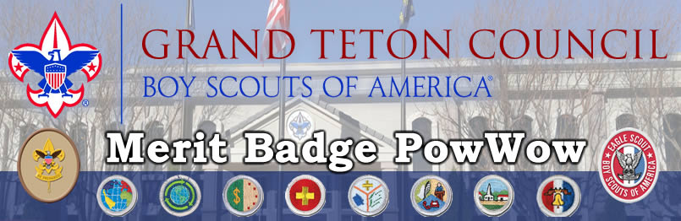

Fall: Sep 28 & Oct 12
Idaho Falls Scout Service Center
3910 S Yellowstone Hwy, Idaho Falls, ID 83402
8:00am until 12:00pm

Register at www.tetonscouts.org

You can take three Merit Badge classes
(except First Aid 3 hrs. and Trail to Eagle)

$25 Registration - $30 After Sep 25
Registration open now

Citizenship in the Community * |  | Citizenship in the Nation * |  | Citizenship in the World *
Communications * |  | Personal Management * |  | Sustainability
Emergency Preparedness * |  | First Aid |  | Astronomy *
Photography * |  | Truck Transportation *1 |  | Art *
Fingerprinting | Personal Health
Trail to Eagle – after Pow Wow. 12:05PM If you are a Life Scout and want help about Eagle Projects etc., bring your workbook. Fourth hour 12:05-12:40.

* Requires work and or visits outside the classroom.
Responsibility is Scouts, parents, or leaders.
For Information:
www.tetonscouts.org
Steve Earl at steve@earls.us
208-542-2585

