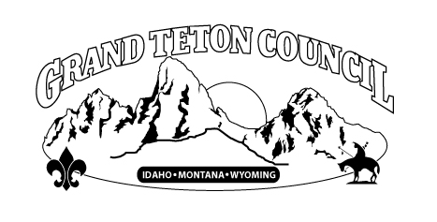

***GRAND TETON COUNCIL, BSA***

*Organizational Hold-Harmless and Indemnity Agreement*

___________________________________ shall indemnify, hold free and harmless, assume liability for, and defend the Boy Scouts of America, Grand Teton Council, and Scouting’s chartered organizations, and any of their affiliates, agents, servants, employees, officers, volunteers, and directors from any and all costs and expenses, including but not limited to, attorneys' fees, reasonable investigative and discovery costs, court costs, and all other sums that the Boy Scouts of America, Grand Teton Council, or Scouting’s chartered organizations, and any of their affiliates, agents, servants, employees, officers, volunteers, and directors incur as a result of any demand for claim or assertion of liability under any municipal, state or federal law or cause of action, including any action under the Americans with Disabilities Act, arising or alleged to have arisen out of any act or omission of, or any use of real or personal property belonging to, the Boy Scouts of America, Grand Teton Council, or Scouting’s chartered organizations, and any of their affiliates, agents, servants, employees, officers, volunteers, and directors.

________________________________ ___________________________  
Name of Rental Group or Organization Name of Contact Person (Print)

________________________________ ___________________________  
Signature Title

________________________________  
Date