2019 Participant Information (Please PRINT)
Name:
Address:
City: |  |  |  |  |  |  | State: |  |  |  |  | Zip:
Phone: |  |  |  |  |  | Cell:
Email Address:
Organization Position or Youth: |  |  |  |  |  |  |  |  |  | Unit: |  |  |  | Age:
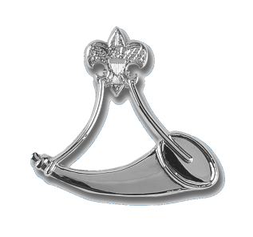
Registration Form

Learning Objectives:
After completing the Powder Horn Course participants should have sufficient introductory information to provide the following outcomes:
Introduction to the necessary skills to
oversee a high adventure program, and
the certifications necessary (and how to
obtain those certifications).
Knowledge of the health and safety
requirements, and rules and regulations
of the Boy Scouts of America as these
apply to outdoor programs.
Knowledge of how to identify local
resources and consultants for outdoor
high adventure activities.

Participant Qualifications:

Be able to meet the physical requirements
of the BSAs Annual Health and Medical Record for a high adventure in a backcountry environment.

Have you ever had your Youth suggest a high adventure activity and thought, “Sounds nice, but I don’t know a thing about it...nor do I know anybody else who does.” Powder Horn can help…
One of the criteria for a high adventure program is “a risk factor for excitement.” The Powder Horn outdoor high adventure skills course is designed to introduce you to the excitement, resources and tools to guide your young adults in a wide range of high adventure program features.
The course covers the following topics:
Archery, backpacking, caving, communications, conservation, cooking, COPE (high & low), mountain biking, ecology, emergency preparedness, equestrian, expedition planning, fishing, land navigation, leave no trace, outdoor living history, plants & wildlife, SCUBA experience, shooting sports, water sports, wilderness first aid, wilderness survival, and MORE!



Enclosed is a $75.00 deposit to confirm my reservation for the 2019 Summer Course. I will pay the balance of $120.00 no later than July 1, 2019.

I understand that this is a physically demanding “high adventure course” that requires medical practitioner approval on a current BSA Annual Health and Medical Record form, prior to “day one” of the course. I affirm that I am registered with the BSA, in good standing, and will have completed the appropriate adult leader training before attending.

Signature: _____________________________

Date: _________________________________

Registration Information

Course Fee: $195.00 Total for the Course
($75.00 Deposit due with application. Balance due 30 days prior to the course “start date.”

Medical Form: Participants MUST submit a current BSA Annual Health and Medical Record (Parts A/B), which should be submitted with final payment 30 days prior to the course.

Course Size: Course will consist of at least 20 and not more than 48 participants. Once the course is filled, participants will be given the option of being placed on a waiting list in case of cancellations.



Mail-In Registrations: Send deposit, registration form, & a copy of your Health and Medical
Record to the: Grand Teton Council, BSA
Course Director - Powder Horn Course
3910 Yellowstone Ave. Idaho Falls, ID 83402

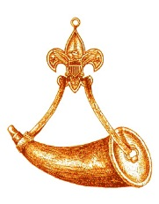



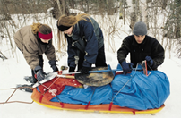
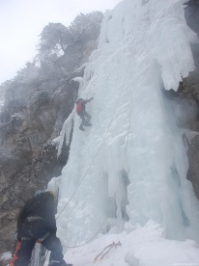
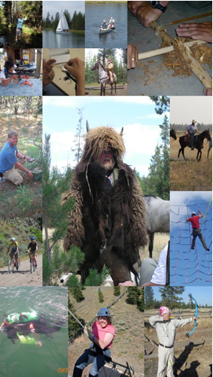



Powder
Horn
POWDER HORN
Why High Adventure for Youth?
A High Adventure Program can teach…
- Decision-making
- Creativity, Discipline
- Leadership, Endurance
- Facing Risk and Uncertainty
- Working in Groups
- Identifying Strengths
- Citizenship, Service
- Concern for others
- Personal Development

Course Director:
Richard Turpin
208-522-5155
Richard.turpin@scouting.org

The powder horn was long used by outdoorsmen as one of the most necessary tools for existence. The powder horn carried the propellant that allowed him to sustain daily life.
The powder horn ranged from the very plain, yet functional, to the ornate work of art, but its use was the same: a Vessel to sustain.
The recipient of the Powder Horn recognition is also a Vessel... to help sustain the spirit of adventure and excitement of the old outdoorsman in our youth.
The propellant that we carry is the knowledge to share with them.
Outdoor High Adventure Skills & Resources Course
Also open to youth
14 – 20 years old
Powder Horn is designed to have many disciplines introduced with numerous hands-on activities. Participants not only actively join in the working sessions, but learn where to go to find those experts or consultants who can teach these skills to Boy Scouts, Varsity Scouts, and Venturers.
A most valuable resource is the consultant, a person whose expertise will teach skills, as well as guide and enhance high adventure experiences.

...is a training course designed to introduce and

expose adult and youth leaders to...

... activities and resources necessary to operate a successful high adventure outdoor program. The Powder Horn course is a resource for all units conducting activities in the outdoors.
It is intended to help adult and youth
leaders become familiar with activities
available to youth, learn how to find
and to use those available resources
in a way that adds variety and
challenges to the youth in unit-level
high adventure programs.

Powder Horn

